**SOFTWARE CONSTRUCTION 2**

**LAB PREPARATION REPORT**

**BY**

**EMMANUEL DURU**

**MATRIC NUMBER: 2502665**

**GROUP 3**

**PROFESSOR WOLFGANG RENZ**

**PROBLEM ONE (B - People): The Code Of This Preparation Is Given Below (Fri-Tree)**

**Triangle triangle1 = new Triangle();**

**triangle1.makeVisible();**

**triangle1.changeSize(40, 30);**

**triangle1.moveUp();**

**triangle1.moveUp();**

**triangle1.moveUp();**

**triangle1.moveUp();**

**triangle1.moveUp();**

**triangle1.moveUp();**

**Triangle triangle2 = new Triangle();**

**triangle2.makeVisible();**

**triangle2.moveUp();**

**triangle2.moveUp();**

**triangle2.moveUp();**

**triangle2.moveUp();**

**triangle2.moveUp();**

**triangle2.moveDown();**

**triangle1.changeSize(50, 40);**

**Triangle triangle3 = new Triangle();**

**triangle3.makeVisible();**

**triangle3.moveUp();**

**triangle3.changeSize(100, 80);**

**triangle3.changeSize(40, 90);**

**triangle3.changeSize(70, 100);**

**triangle3.moveUp();**

**THE FRI TREE:**

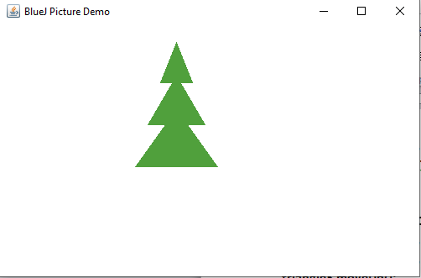

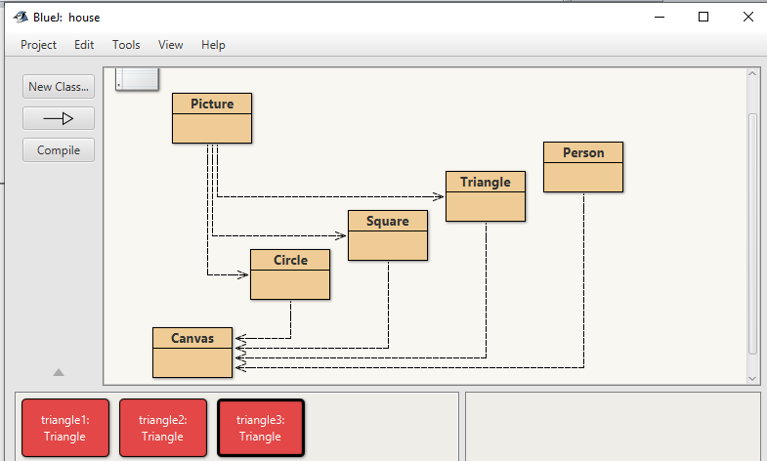

**PROJECT TWO (A and B): the three parts of the class implementation are given below**

* **Object constructors**
* **Method of readjusting the classes to make an accurate picture class.**
* **Variables**

**PROJECT TWO: B (USAGE):**

**Basically I would say that the picture object was derived from different classes by instantiating the classes of (circle, square, triangle), making them visible and setting it up the methods to form an object of picture.**